**Sri Lanka Institute of Information**

**Technology**



3 Year 2nd Semester - 2025 February

**Programming Applications and Frameworks ( IT3030 )**

Group Id - DS 07

Skill-Sharing & Learning Platform

**Flavorflow** **- Cooking & Recipe Learning**

Initial Document

**- Group Details -**

|  |  |
| --- | --- |
| **Name** | **IT Number** |
| **Fernando W.D.A** | **IT22223708** |
| **Jayasinghe J.M.N.S** | **IT22582942** |
| **Gamage D.M.G.P.K** | **IT22188472** |
| **Perera B.B.A.R** | **IT22606792** |

**Table of Contents**

*1. Project Description 3*

*2. Functional Requirements 4*

*2.1 Client Web Application (React) 4*

*2.2 REST API (Spring Boot Backend) 5*

*3. Non-Functional Requirements. 6*

*3.1 Client Web Application ( React ) 6*

*3.2 Rest API ( Spring Boot Backend ) 6*

*4. Project Distributions 7*

*• Cooking Recipe & Skill Sharing Management 7*

*• Social Interactions (Likes, Comments, Follow/Unfollow) 7*

*• Learning Plan Management (Structured, Shared Learning Flow) 7*

*• User Profiles, Notifications, and System Access Control 8*

*5. System Overview Diagram. 9*

*6. Gantt Chart 9*

1. **Project Description**

Modern people access digital online platforms to obtain new skills and demonstrate their knowledge and passion to others as digital technology advances. Among life skills which people constantly pursue cooking stands out as an important medium that creates opportunities for creativity and culture transmission while enabling individual personal growth. The project by our team delivers "Flavorflow " to create a modern Cooking Skills Sharing and Learning Platform which facilitates interactive connections among home chef learners and cooking enthusiasts.

Users have the option to post their recipes alongside their cooking methods, and kitchen advice and upload images in addition to brief cooking videos for inspiration. Users can track their cooking skills development plan individualized culinary activities and interact with other members by using features for liking content leaving comments and following profiles. The built-in notification function allows users to receive real-time updates on every interaction along with ongoing platform activities. The system uses OAuth 2.0-based social login authentication for security purposes and convenient access.

Flavorflow seeks to establish an enthusiastic culinary learning group dedicated to reshaping how people discover and advance their cooking skills and expertise.

1. **Functional Requirements**

**2.1 Client Web Application (React)**

These are the functionalities that users will interact with via the frontend interface.

|  |  |  |
| --- | --- | --- |
| **User Management & Authentication** | | |
| 01 | User Authentication | Google or Social media button integration, redirects on successful login. |
| 02 | Profile Management | View and edit profile, see own posts and learning updates. |

|  |  |  |
| --- | --- | --- |
| **Content Creation and Sharing** | | |
| 03 | Skill Sharing and post-creation | Users can create and publish skill-sharing posts with Texts / Images and Videos. |
| 04 | Learning progress updates | Interface to update personal learning progress on specific skills or topics. |
| 05 | Learning Plans | UI to create, edit, and display personal or shared learning plans. |

|  |  |  |
| --- | --- | --- |
| **Notification and User Engagement** | | |
| 06 | Notification Interface | UI notification bell or dropdown to display alerts.  ( likes, Comments, New followers ) |

|  |  |  |
| --- | --- | --- |
| **Social and Interactive Features** | | |
| 07 | Commenting and liking | Users can like posts or add comments through intuitive UI elements. |
| 08 | Skill Feed View | Dynamic feed Displays all posts from followed users or global feed. |
| 09 | Social Interaction | Follow / Unfollow Buttons, Display Follower(s) / Following Counts. |

|  |  |  |
| --- | --- | --- |
| **UI / UX and Frontend Enhancement** | | |
| 10 | Responsive Design | Full mobile and desktop responsiveness using CSS frameworks. |

## **2.2 REST API ( Spring Boot Backend )**

|  |  |  |
| --- | --- | --- |
| **Authentication and User Management** | | |
| 01 | OAuth 2.0 Authentication | API routes to handle OAuth token validation, and user creation on the first login. |
| 02 | User Management | REST endpoints for get/update profile, and follow /unfollow actions. |
| 03 | Role-Based Access Control | Optional admin privileges for platform moderation features. |

|  |  |  |
| --- | --- | --- |
| **Content Management** | | |
| 04 | Post Management | CRUD APIs for skill-sharing posts. |
| 05 | Comment and Like APIs | Endpoints to Like/Unlike and post/delete comments on posts. |

|  |  |  |
| --- | --- | --- |
| **Learning and Progress Tracking** | | |
| 06 | Learning Progress APIs | Create, Update, and fetch learning progress records for users. |
| 07 | Comment and Like APIs | Endpoints to manage learning plans: add goals, step, and deadlines |

|  |  |  |
| --- | --- | --- |
| **User Interaction and Notifications** | | |
| 08 | Notification APIs | Generate and Fetch notification data based on actions like comments/likes/follows. |

|  |  |  |
| --- | --- | --- |
| **File and Media Handling** | | |
| 09 | File Handing | APIs for image/media upload and retrieval. |

|  |  |  |
| --- | --- | --- |
| **API Documentation and Testing** | | |
| 10 | API Documentation | Swagger UI / Open AI spec to document and test endpoints. |

1. **Non-Functional Requirements.**
   1. **Client Web Application ( React )**

|  |  |
| --- | --- |
| **Requirement** | **Description** |
| Usability | Easy-to-navigate interface with clear icons, buttons and Layouts |
| Performance | Minimal loading time via lazy loading and optimized bundle size. |
| Accessibility | WCAG standards: keyboard navigation, alt-text, colour contrasts. |
| Responsiveness | Adaptive UI across all device sizes using responsive CSS frameworks. |
| Maintainability | Modular react components, reusable hooks, clean code structure. |
| Scalability | Can easily add new pages/features with routing and modular design. |
| Error Handling | User-friendly error message and fallback UIs. |
| Security | Secure storage of auth tokens, and prevent XSS/CSRF. |

* 1. **Rest API ( Spring Boot Backend )**

|  |  |
| --- | --- |
| **Requirement** | **Description** |
| Performance | Optimized DB queries, catching and asynchronous processing where necessary. |
| Security | OAuth 2.0-based access control, HTTPS usage, input validation |
| Scalability | Layered architecture (Controller > Service > Repository) enabling horizontal scaling. |
| Maintainability | Clean package structures (Controllers > Service > Models), properly commented code. |
| Reliability | Exception handling mechanisms to avoid server crashes and provide graceful fallback. |
| API Rate Limiting | Optional to control abuse/spam and prevent DDoS. |
| Logging and Monitoring | Log errors, requests, and service health (Spring Actuator, Logback) |
| API Documentation | Swagger/OpenAI for easy API testing and team collaboration. |

1. **Project Distributions**

* **Cooking Recipe & Skill Sharing Management**

This function enables users to create and manage cooking recipes while sharing

their skills with the community. Users can create detailed recipe posts, including ingredients, descriptions, and media files (images/videos).

The system allows for easy updating, deletion, and retrieving of all recipes. Additionally, users can upload media files to enhance their posts. With a user-friendly interface and efficient functionality, this platform fosters an engaging and interactive cooking experience.

* **Social Interactions (Likes, Comments, Follow/Unfollow)**

The platform implements interactive social functionalities to the Flavorflow website which improves user participation within the community. Through this feature, users can perform three actions including commenting on cooking posts, liking them, replying to comments and following or unfollowing different users. The implemented features drive user engagement because they provide multiple ways for visitors to engage with content as well as build appreciation networks and maintain connections with their preferred content creators. The system enables owners of posts to receive alerts when their content receives engagement from others through optional notification settings.

* **Learning Plan Management (Structured, Shared Learning Flow)**

The Function enables planners to generate structured learning plans which they can organize and distribute so learners can proceed through the steps in order. Users benefit from this system through its smooth development of learning experiences to complete essential steps in their desired sequence.

This function has three essential sections which form its operating structure.

Learning Plan Creation and Sharing.

Plan creators establish complete learning operations while defining lesson content with planned duration times for each lesson segment. The creators maintain complete authority to edit their plans alongside the ability to both update and delete them as well as distribute them to students.

Plan Attempting

Learners progress through specified milestones in sequential order according to set time frames before they advance to the next step.

Track Progress

Students view their achievement levels as they mark step completion while they see upcoming work and monitor the remaining time until they advance to the next task.

* **User Profiles, Notifications, and System Access Control**

This function manages user onboarding, authentication, profile management, notifications, and role-based access control to ensure a personalized and secure user experience.

User Authentication & Profile Management:

* + 1. Users sign up and log in using OAuth2 (Google, Facebook, etc.).
    2. Allows users to view, update, and manage their profiles.
    3. Soft delete option for user accounts.

Notifications System:

* + 1. Sends real-time notifications for interactions

(e.g., likes, comments, new followers).

* + 1. Users can view notifications and mark them as read.

Role-Based Access Control (RBAC)

* + 1. Assign user roles

(e.g., planner for recipe creators, learner for followers).

* + 1. Ensures access control for role-specific features.

This function manages user authentication, profiles, notifications, and access control to ensure a seamless and secure user experience. Users can sign up or log in using OAuth2 and create a personal profile. They can view, update, or delete their profile when needed. The system sends real-time notifications for interactions like likes, comments, and new followers, which users can view and mark as read. Additionally, role-based access control assigns users as planners (meal creators) or learners (followers), ensuring they have the right permissions to access specific features.

|  |  |  |  |
| --- | --- | --- | --- |
|  | **IT Number** | **Member Name** | **Responsibilities** |
| **1** | **IT22223708** | **Fernando W.D.A** | * **Social Interactions (Likes, Comments, Follow/Unfollow)** |
| **2** | **IT22582942** | **Jayasinghe J.M.N.S** | * **Cooking Recipe & Skill Sharing Management** |
| **3** | **IT22188472** | **Gamage D.M.G.P.K** | * **Learning Plan Management** |
| **4** | **IT22606792** | **Perera B.B.A.R** | * **User Profiles, Notifications, and System Access Control** |

1. **System Overview Diagram.**

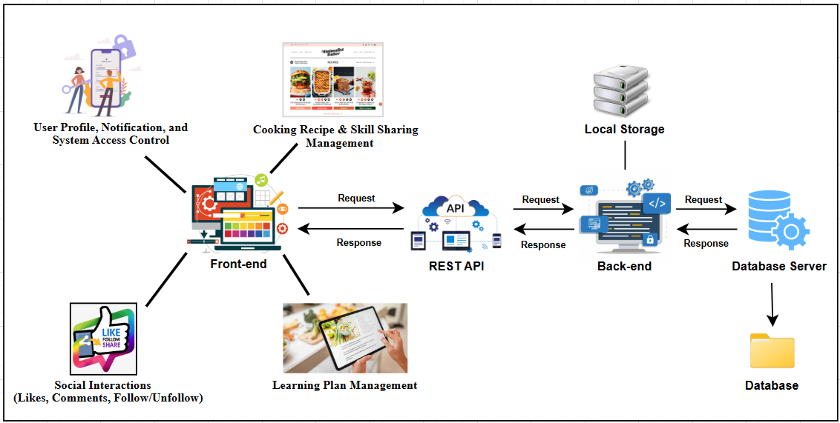

[***https://drive.google.com/file/d/13pebL8fW_L6PMoFs2eA7n3uL2p8vNyV6/view?usp=sharing***](https://drive.google.com/file/d/13pebL8fW_L6PMoFs2eA7n3uL2p8vNyV6/view?usp=sharing)

1. **Gantt Chart**

|  |  |  |  |  |  |  |  |  |
| --- | --- | --- | --- | --- | --- | --- | --- | --- |
| Phase | Estimated Duration | | | | | | | |
| Week 1 | Week 2 | | Week 3 | Week 4 | Week 5 | Week 6 | Week 7 |
| Project Planning |  |  | |  |  |  |  |  |
| System Design |  | |  |  |  |  |  |
| Database Design & Setup |  |  | |  |  |  |  |  |
| Backend Development |  |  |  | |  |  |  |  |
| Frontend Development |  |  | |  |  | |  |  |
| Integration Phase |  |  | |  |  |  |  |  |
| Testing & Debugging |  |  | |  |  |  |  |
| Deployment |  |  | |  |  |  |  |  |
| Final Report |  |  | |  |  |  |  |

***